**Object destructuing**

object destructuing is a type of assignment destructuring which is used to **destructurise** the object to its values and **assign** these values to a bunch of variables **in** **respectively**.

**Syntax:**

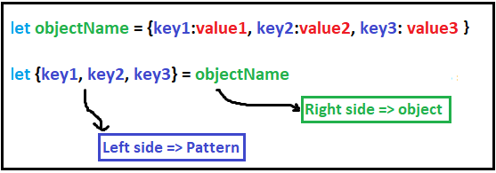

**Where:**

* value1 = objectName.key1
* value2 = objectName.key2
* value3 = objectName.key3

**Example 1:**

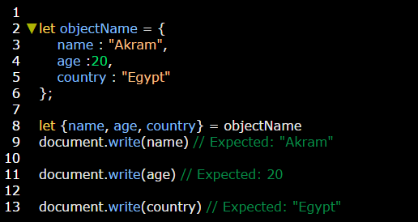

**Note:** The order of keys in the pattern in left side is not matter does not matter.

**Example:**

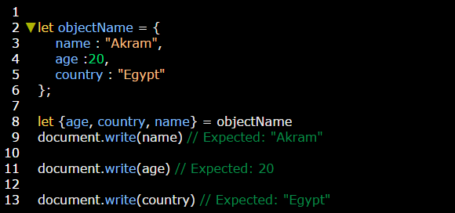

**Note:** if you want to change the key name in pattern we use colon.

**Example:**

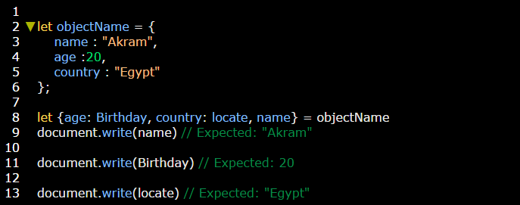

**Note:** you can cancel value by doesn’t write it’s key, because using canceled comma with objects giving an error.

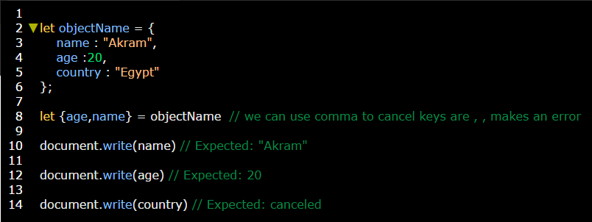

**Note:** we can determine a “default” value to replace the missing one, by using **=** operator.

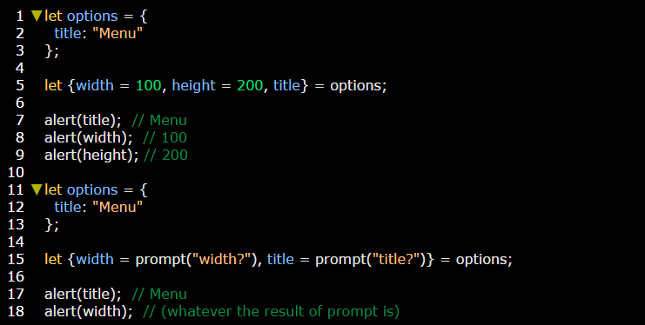

**Note:** We also can combine both the colon and equality:

**Example:**

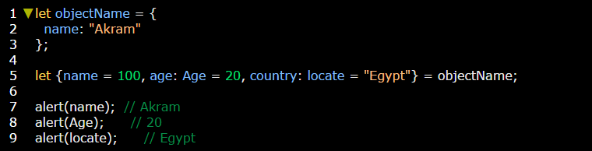

**Note:** If we have a complex object with many properties, we can extract only what we need:

**Example:**

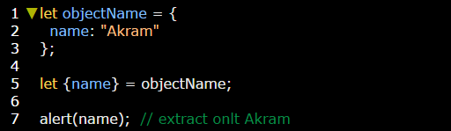

**Note:** you can use **…variable** to get rest values without keys, in this case **…variable** will treated as a *separated object.*

Note also that this trick is not supported by some older browsers (IE, use Babel to polyfill it), but works in modern ones.

**Example:**

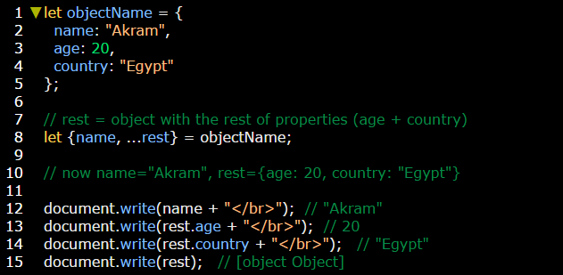

**Note:** if let keyword was omitted an error occurs.

**Example:**

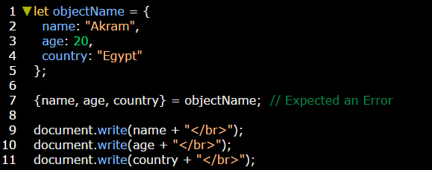

The reason of that error is **{…}** considered a [block scope](../../../Scope%20in%20JavaScript.docx) and because variable of the pattern (left side) locate inside **block** and the output statement locate inside the **global** scope, the output statement has no accessibility to this variable. (Variable wasn’t visible for the output statement).

|  |  |  |
| --- | --- | --- |
| Variable scope | Output statement scope | result |
| **block** | **global** | Error |

We can solve this problem by using **( ).**

**اتأكد من السبب دا عشان الكلام المكتوب دا هبد. خد اللينك اهو** <https://javascript.info/destructuring-assignment>

**Example:**

